Higher Nationals
Internal verification of assessment decisions – BTEC (RQF)
INTERNAL VERIFICATION – ASSESSMENT DECISIONS
Programme title | BTEC Higher National Diploma in Computing
Assessor | Ms. Harshi Perera |  | Internal Verifier |  | Ms. Sandali Fernando
Unit(s) | Unit 03: Professional Practice
Assignment title | Work Related Learning Report: Design and Deliver a Training Programme
Student’s name | P. Nipuni Nethmini / KLT00209710
List which assessment criteria the Assessor has awarded. | Pass |  | Merit |  |  |  | Distinction
INTERNAL VERIFIER CHECKLIST
Do the assessment criteria awarded match those shown in the assignment brief? |  | Y/N
Is the Pass/Merit/Distinction grade awarded justified by the assessor’s comments on the student work? |  | Y/N
Has the work been assessed accurately? |  | Y/N
Is the feedback to the student:  Give details:  - Constructive?  - Linked to relevant assessment criteria?  - Identifying opportunities for improved performance?  - Agreeing actions? |  | Y/N Y/N  Y/N Y/N
Does the assessment decision need amending? |  | Y/N
Assessor signature |  |  |  |  |  | Date
Internal Verifier signature |  |  |  |  |  | Date
Programme Leader signature (if required) |  |  |  |  |  | Date

Confirm action completed
Remedial action taken

Give details:
Assessor signature |  | Date
Internal Verifier signature |  | Date
Programme Leader signature (if required) |  | Date

Higher Nationals - Summative Assignment Feedback Form
Student Name/ID |  | P. Nipuni Nethmini / KLT00209710
Unit Title |  | Unit 03: Professional Practice
Assignment Number |  | 1 | Assessor |  | Ms. Harshi Perera
Submission Date |  | 2024/04/09 | Date Received 1st submission
Re-submission Date |  |  | Date Received 2nd submission
Assessor Feedback:
LO1 Demonstrate a range of interpersonal and transferable communication skills to a target audience
Pass, Merit & Distinction Descripts | P1 | P2 | M1 | D1
LO2 Apply critical reasoning and thinking to a range of problem-solving scenarios
Pass, Merit & Distinction Descripts | P3 | P4 | M2 | M3 | D2
LO3 Discuss the importance and dynamics of working within a team and the impact of team working in different environments
Pass, Merit & Distinction Descripts | P5 | P6 | M4 | D3
LO4 Examine the need for Continuing Professional Development (CPD) and its role within the workplace and for higher level learning
Pass, Merit & Distinction Descripts | P7 | P8 | P9 | M5 | D4

Grade: | Assessor Signature: |  |  | Date:
Resubmission Feedback:

Grade: | Assessor Signature: |  |  | Date:
Internal Verifier’s Comments:
Signature & Date:
* Please note that grade decisions are provisional. They are only confirmed once internal and external moderation has taken place and grades decisions have been agreed at the assessment board.

Assignment Feedback
Formative Feedback: Assessor to Student

Action Plan

Summative feedback

Feedback: Student to Assessor

Assessor signature |  | Date
Student signature |  | Date

Pearson Higher Nationals in
Computing

Unit 03: Professional Practice
Assignment 01

General Guidelines

- A Cover page or title page – You should always attach a title page to your assignment. Use previous page as your cover sheet and make sure all the details are accurately filled.
- Attach this brief as the first section of your assignment.
- All the assignments should be prepared using a word processing software.
- All the assignments should be printed on A4 sized papers. Use single side printing.
- Allow 1” for top, bottom , right margins and 1.25” for the left margin of each page.
Word Processing Rules

- The font size should be 12 point, and should be in the style of Time New Roman.
- Use 1.5 line spacing. Left justify all paragraphs.
- Ensure that all the headings are consistent in terms of the font size and font style.
- Use footer function in the word processor to insert Your Name, Subject, Assignment No, and Page Number on each page. This is useful if individual sheets become detached for any reason.
- Use word processing application spell check and grammar check function to help editing your assignment.
Important Points:

- It is strictly prohibited to use textboxes to add texts in the assignments, except for the compulsory information. eg: Figures, tables of comparison etc. Adding text boxes in the body except for the before mentioned compulsory information will result in rejection of your work.
- Carefully check the hand in date and the instructions given in the assignment. Late submissions will not be accepted.
- Ensure that you give yourself enough time to complete the assignment by the due date.
- Excuses of any nature will not be accepted for failure to hand in the work on time.
- You must take responsibility for managing your own time effectively.
- If you are unable to hand in your assignment on time and have valid reasons such as illness, you may apply (in writing) for an extension.
- Failure to achieve at least PASS criteria will result in a REFERRAL grade .
- Non-submission of work without valid reasons will lead to an automatic RE FERRAL. You will then be asked to complete an alternative assignment.
- If you use other people’s work or ideas in your assignment, reference them properly using HARVARD referencing system to avoid plagiarism. You have to provide both in-text citation and a reference list.
- If you are proven to be guilty of plagiarism or any academic misconduct, your grade could be reduced to A REFERRAL or at worst you could be expelled from the course

Student Declaration

I hereby, declare that I know what plagiarism entails, namely to use another’s work and to present it as my own without attributing the sources in the correct form. I further understand what it means to copy another’s work.

- I know that plagiarism is a punishable offence because it constitutes theft.
- I understand the plagiarism and copying policy of Edexcel UK.
- I know what the consequences will be if I plagiarise or copy another’s work in any of the assignments for this program.
- I declare therefore that all work presented by me for every aspect of my program, will be my own, and where I have made use of another’s work, I will attribute the source in the correct way.
- I acknowledge that the attachment of this document signed or not, constitutes a binding agreement between myself and Pearson, UK.
- I understand that my assignment will not be considered as submitted if this document is not attached to the assignment.

Student’s Signature: Date:
(Provide E-mail ID) (Provide Submission Date)

Higher National Diploma in Business
Assignment Brief
Student Name /ID Number | P. Nipuni Nethmini / KLT00209710
Unit Number and Title | Unit 3: Professional Practice
Academic Year | 2022/23
Unit Tutor | Ms. Harshi Perera
Assignment Title | Work Related Learning Report: Design and Deliver a Training Programme
Issue Date | 2024/02/15
Submission Date | 2024/04/11
IV Name & Date | Ms. Sandali Fernando

Submission format

The submission should be in the form of an individual report written in a concise, formal business style using single spacing (refer to the assignment guidelines for more details). You are required to make use of headings, paragraphs and subsections as appropriate, and all work must be supported with research and referenced using Harvard referencing system. Please provide in-text citation and a list of references using Harvard referencing system. Please note that this is an activity-based assessment and your report should include evidences to the activities carried out individually and/or in a group.
To carry out the activities given on the brief, you are required to form groups, comprising maximum of 6 members.

Unit Learning Outcomes:

LO1 Demonstrate a range of interpersonal and transferable communication skills to a target audience.
LO2 Apply critical reasoning and thinking to a range of problem-solving scenarios.
LO3 Discuss the importance and dynamics of working within a team and the impact of team working in different environments.
LO4 Examine the need for Continuing Professional Development (CPD) and its role within the workplace and for higher-level learning.

Scenario
Assume yourself as the event coordinator working in an event planning organization specialized in delivering trainings on IT and soft skills. you have been appointed to design and deliver a training event on IT /Soft Skills to an identified audience. You are required to complete the project within 2 months and the training plan and resources should be finalized as per the requirement of the client.
You are required to form a group of not more than 10 members in order to carry out the event. The event will be headed by an event manager/ leader and each group member will be assigned a set of tasks. While designing and delivering the event,
- the skills required to make the event successful
- challenges faced during the design/ delivery
- Critical evaluation of the problems, challenges faced and the methods used to overcome them
- The need for continuously develop in a professional environment
Need to be thoroughly considered.
At the end of the event, produce an individual report by each member covering the following tasks.
Task 1:
Demonstrate how you are planning to effectively deliver the training event by designing a professional project plan with following details.
- Roles appointed to group members and an evaluation of interpersonal skills of each member that justifies the assigned role in the team.
- Goal and objectives of the project
- Evidence to the communication styles and formats used to communicate with the client and the team members and the findings/ outcomes of the communications.
- Challenges/ problems identified and the plan to overcome them
- A professional project schedule with the activities, milestones and contingencies identified to demonstrate the effective time management skills in order to plan the training.

Task 2
Research different problem-solving techniques that can be used to solve the identified problems in task 1 and demonstrate how critical reasoning can be applied to identify a solution to the identified problems in planning and designing of the training event.
Critically evaluate the solution methodology used to solve one of the identified problems and justify how selected methodology helped you to successfully solve the problem and achieve the project objectives.
Task 3
Work in your team by contributing your skills and knowledge to meet the project goal. Critically evaluate your own role and contribution to the group for the completion of the training event.
Discuss the importance of having dynamic team members in a group to meet its goals by referring to the role assigned to the group members and analyse how team dynamics among your group members effectively helped to achieve the shared project goal.
Task 4
Discuss with examples, the importance of continuous professional development (CPD) in a work setting by evaluating the range of CPD criteria that can be used to measure the effectiveness of your employees in your organization.
Produce a continuous professional development (CPD) plan using the criteria identified above with relevant to the responsibilities, required skills, performance objectives for the members of your team. Review different motivational theories and discuss how they can be helpful to improve the performance of the team members and meet the objectives of the developed CPD plan. Justify how the developed CPD supports in building the motivation of your team.

Acknowledgement

I want to start by thanking Ms. Harshi Perera, our Professional Practice lecturer, for helping us with this project and teaching us the lessons. She is very knowledgeable person and kind to everyone.
In addition, I want to thank my group members for contributing to the success of this event. I learned a lot from this assignment and it helped me get better at communicating. It was an excellent educational opportunity that I thoroughly appreciated. I would like to express my gratitude to Esoft Metro Campus for this invaluable opportunity.

Abbreviations
CPD Continuing Professional Development
CPA Critical Path Analysing
PDP Personal Development Plan
HND Higher National Diploma
Table of Contents
Introduction 18
1. Demonstrate how you are planning to effectively deliver the training event by designing a professional project plan with following details. 19
1.1. The Training Event 19
1.2. Goal and the Objectives 19
1.3. The Professional Schedule 20
1.4. Roles and Responsibilities 21
1.5. Justification of the team roles and selection 23
1.6. Challenges Faced 24
1.7. Different interpersonal and communication skills 24
1.8. Self-reflection of interpersonal skills 25
2. Critically evaluate the solution methodology used to solve one of the identified problems and justify how selected methodology helped you to successfully solve the problem and achieve the project objectives. 26
2.1 Problem solving skills 26
2.2. SWOT Analysis 26
The Drill down Technique 27
2.3. Applying critical reasoning 28
2.4. Process of applying critical reasoning 28
3. Work in your team by contributing your skills and knowledge to meet the project goal. Critically evaluate your own role and contribution to the group for the completion of the training event. 31
3.1. Team Dynamics and Critical Evaluation 31
3.2. Self-Evaluation of Role and contribution 31
3.2. Importance of Dynamic Team Members 32
3.3. Justification of Methodologies 33
3.4. Evaluation of Event Success 33
3.5. Talk about Team Dynamic 34
4. Discuss with examples, the importance of continuous professional development (CPD) in a work setting by evaluating the range of CPD criteria that can be used to measure the effectiveness of your employees in your organization. 36
4.1. What is CPD 36
4.2. Importance of CPD 36
4.4. Personal Development plan (PDP) 38
4.5. Motivational theories 39
4.6. Impact they can have on performance within the workplace 47
Annexure 49
1. Meeting Minutes Annexure 49
2. Project Proposal 57
Table of Contents 58
Our team 59
Introduction 60
Problem statement 61
Objectives 61
Plan of action 62
Management plan 63
Conclusion 65
Project approval 66
3. Event Photos 67
Soft Skill Development Program 67
Hardware Show 68
VR Show 69
Quiz Program 70
Ardino Show 71
4. Approval Letter 73
Bibliography 75

List of Figures

Figure 1 SMART CHART 22
Figure 2 Gantt Chart 23
Figure 3 Drill down technique (Moreno, 2018) 30
Figure 4 critical path analysing chart 32
Figure 5 motivational theory 1 42
Figure 6 motivational theory 2 42
Figure 7 motivational theory 3 43
Figure 8 motivational theory 4 43
Figure 9 motivational theory 5 44
Figure 10 motivational theory 6 44
Figure 11 motivational theory 7 45
Figure 12 motivational theory 8 45
Figure 13 motivational theory 9 46
Figure 14 motivational theory 10 46
Figure 15 motivational theory 11 47
Figure 16 motivational theory 12 47
Figure 17 motivational theory 13 48
Figure 18 motivational theory 14 48
Figure 19 soft skill development program 69
Figure 20 hardware show 70
Figure 21 vr show 71
Figure 22 quiz program 72
Figure 23 ardino show 73
Figure 24 74
Figure 25 74
Figure 26 75
Figure 27 Approval letter 76

List of Tables
Table 1 Team members according to Belbin’s Team Roles 23
Table 2 Critical path analysing of our event 30
Table 3 personal development plan 40
Table 4 comparison motivational theories 48
Table 5 First meeting minutes 51
Table 6 second meeting minutes 54
Table 7 third meeting minutes 56
Table 8 Event schedule 64
Table 9 Budget plan 65

Introduction

Professional practice is introduced in this unit. Pupils will have the chance to hone essential workplace competencies including networking, communication, teamwork, and decision-making. In addition to researching businesses, organizations, and professions, students will self-evaluate their personal qualities, values, and abilities. They will also plan and create goals for their careers. With the unit, students will be able to start to comprehend the evolving nature of work and their own professional identities. As a component of their education, the course will give students the necessary groundwork to complete a successful practical experience in the workplace.
"Professional practice" is a subject that helps us become more skilled and knowledgeable about how to handle obstacles. Soft skills are an essential set of abilities while working with real-world situations.
We conducted extensive study to determine who would benefit most from our training session. Following deliberation among the team members, the decision was made to select Kalutara Balika Vidyalaya A/l students as the designated audience for the event. The Kalutara Balika Vidyalaya in the Kaltura district is classified as a D grade school.
This project covers all of the aforementioned objectives, and it was quite engaging. It also allowed us to obtain a great deal of information and expertise. In my opinion, this event has greatly improved my soft skills.

Demonstrate how you are planning to effectively deliver the training event by designing a professional project plan with following details.

The Training Event

Initially, our team convened and deliberated on the project's framework. Our success, we believed, depended on having an early conversation to identify each person's strengths and shortcomings. Choosing a school that could accommodate our needs was the first big task we had to perform as a team.
When we had a good understanding of each other's strengths and shortcomings, we decided to elect a team leader first. The project idea was organized when we all got together one day. We had to make additional changes to the project plan after improving the proposal further and getting permission to hold the event from Kalutara Balika Vidyalaya's principal. based on the instructions the principle provided.
We sought assistance from the school's teachers in order to locate pupils who would be open to taking part in activities or games. Every student received guidance from our team on which event to attend. As the Our team members provided advice on how to take part as well. The events were organized with the goal of developing all the necessary soft skills.

Goal and the Objectives

Setting clear direction and purpose for individuals or organizations is facilitated by the use of goals and objectives. A goal is a comprehensive declaration that outlines the long-term objectives of a person or organization. Their vision for the future is to give a general direction.
While goals are more general in nature, objectives are more focused, quantifiable, realistic, pertinent, and have a time limit. They divide the objectives into more manageable, assessed-and-reviewable segments.
To summaries, objectives are particular targets that aid in the successful achievement of goals, whereas goals offer the overall direction.

To make our project more attainable, we employed the S.M.A.R.T. goals method.
• Specific (clear, logical, and noteworthy).
• Measurable (purposeful, inspiring).
• Attainable (decided upon, achievable).
• Relevant (reasonable, practical, resource-based, and results-driven).
• Time-bound (time-sensitive, timely, cost-and time-limited, time-based).
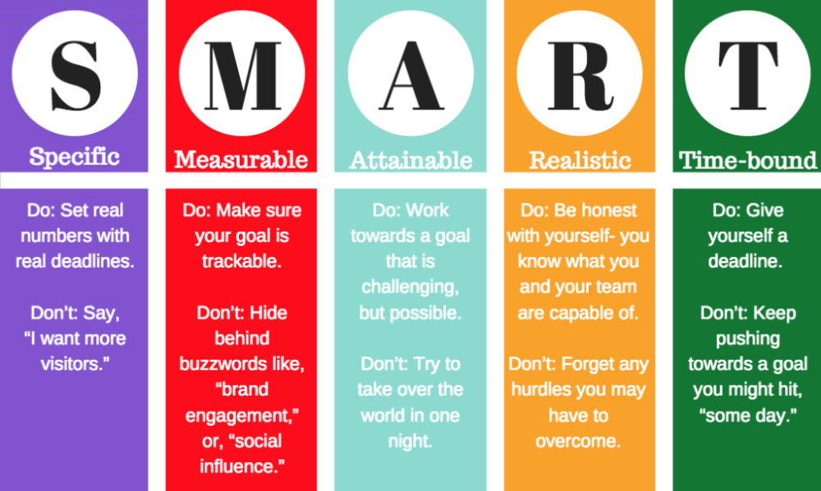
Figure 1 SMART CHART
(SHEVONEESE, 2019)

The Professional Schedule

Professional schedules are lists of specific goals with dates for beginning and ending or for a specific period of time. Setting out our timetable properly was crucial to ensuring that we completed the project efficiently and without being overly stressed by impending deadlines that would have interfered with our personal lives or other obligations.
Here is the Gantt chart that we created and employed as a project management tool for this endeavor.
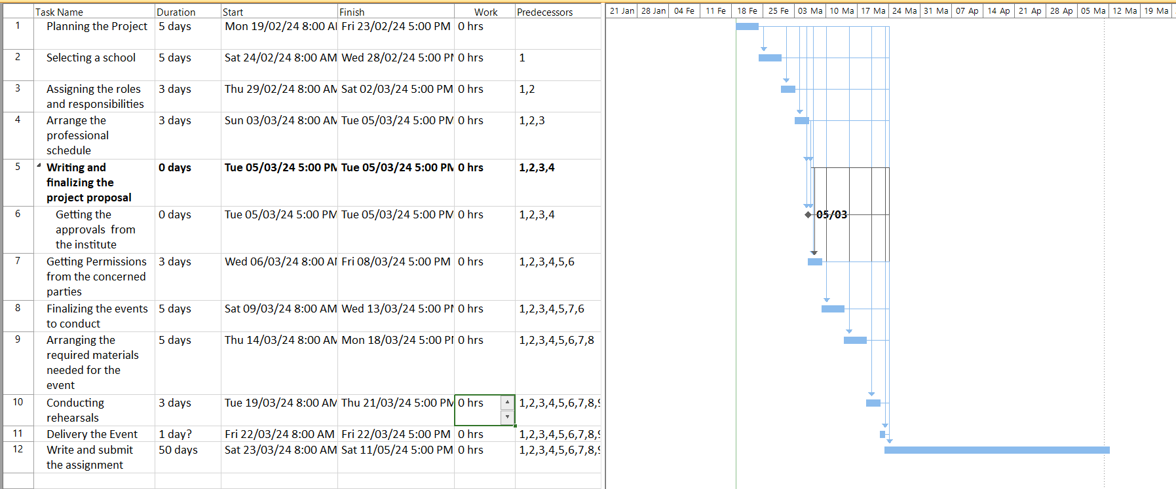
Figure 2 Gantt Chart

Roles and Responsibilities

The leader chosen was H.H. Samitha Dulakshana. The duties of the lead are listed below.
1. Establishing precise goals and objectives for the group.
2. Giving team members direction, advice, and encouragement.
3. Effectively assigning responsibilities to others and making sure that the work is done so fairly.
4. Tracking the progress of the team and offering constructive criticism.
5. Handling disagreements and other problems that may come up inside the group.
6. Motivating team members to cooperate, communicate, and work as a unit.
Belbin’s Team Roles Model
Nine distinct roles that people might take on within a team are identified by Dr. Meredith Belbin's idea, known as the Belbin's Team Roles Model. The talents and behaviors that people display in a group environment are used to categorize these roles.
As a result, we defined our team and identified our strengths and shortcomings using the Belbin model. The table below illustrates our approach.
Team Role | Description | Team member’s name
Plant | An imaginative and creative thinker who comes up with concepts and fixes. | Dilan Rajitha
Resource Investigator | gregarious, inquisitive person who looks for networks and opportunities. | Gishan Weeraratna
Coordinator | Ensures team cohesiveness by efficiently planning and assigning duties. | Thimash Shanuka  Sasini dulanjana
Shaper | An enthusiastic and dynamic person who pushes the group to grow and accomplish objectives. | Sanjale Samindara  Deshan
Monitor Evaluator | Critical thinker who supports decision-making and offers critical analysis | Rumana Begum
Team Worker | A helpful and cooperative team player that encourages unity and cooperation. | Tharunethmi Apurwa  Nethmi Malsha  Nipuni Nethmini  Sandun Chathura  Chameera Fernando  Ashen Pradeepa  Akash Pahasara  Yenuka Rangana  Abdul Azees
Implementer | A dependable, realistic person who puts ideas into practice. | Dilshan Chathuranga
Completer Finisher | Meticulous and responsible team player that makes sure assignments are finished to a high calibre. | Anfal
Specialist | An informed professional with specialised knowledge and abilities in a particular field. | Eshan Fernando
Table 1 Team members according to Belbin’s Team Roles

Justification of the team roles and selection

When deciding which tasks each team member should complete, we took into account both their comfort level and level of skill. Fortunately. On the roles they were assigned, everyone in our group was in agreement. The key things we took into account when assigning each member their respective tasks are listed below.
1. Specify the Tasks
We created an outline of the primary duties, supporting duties, and the order in which they needed to be completed.
2. Our limitations, shortcomings, and areas of strength
Honesty regarding one's abilities, capabilities, and shortcomings was something we encouraged among our members.

We had an excellent leader in Samitha. Whenever a different suggestion was given by the majority or when a different point of view made more sense, he listened to the other team members and made adjustments to his original plan. Taking great care to ensure that none of the members were appointed to jobs felt self-conscious about their position on the squad.
The project coordinator choice was made after Sasini and Thimash. Ensuring that all project-related activities are carried out successfully and with sufficient communication was the coordinator's responsibility. Whenever needed, Sasini and Thimash were a highly motivated individual who was ready to engage in conversation and do tasks. An unsuccessful endeavour would have resulted from her failure to keep an eye on things.
Gishan's job experience and practical understanding of resource utilisation played a major role in his appointment as the Resource Investigator. His role was to draw teams' attention to methods and tools that make tasks easier to complete. Furthermore, he provided input on the theoretical. He examined the ideas that the other members had provided, taking into account our financial and scheduling limitations.
Tarunethmi, Nethmi, and I were chosen to help with the financial management because our organisation needed three assistants for that. We all three had the necessary quantity of money to finish the programme since we all used it methodically. It took place. Together, the three of us gave the group excellent financial management support.

For all other graphic design needs during the project, such as creating stage backdrops and presentations, we also required two graphic designers. Both of our graphic designers, Pahasara and Dilan, have extensive experience with digital graphics in addition to having excellent artistic sense. creative software, like GIMP and Adobe Photoshop.

Challenges Faced

Because of Challenges, we grew stronger. We encountered numerous difficulties right from the start of the project. Since we were all aware that difficulties might occasionally arise, we were prepared for them. Selecting a school presented our first challenge. We are prepared to complete the task at hand. We found it challenging to get a date for each school's term exams while we were there.
However, because our group leader and all of us collaborated, we were assigned a deadline to complete the Kalutara Girls' College project. Selling the wristbands and bookmarks to raise the money needed for the project presented us with a new obstacle.

Different interpersonal and communication skills

Interpersonal skills refer to the ability to interact effectively with others, build positive relationships, and work well in a team. This includes skills such as active listening, empathy, conflict resolution, collaboration, and adaptability.
Communication skills involve the ability to convey information clearly and effectively to others. This includes verbal communication, non-verbal communication, written communication, active listening, and the ability to tailor your message to different audiences. Good communication skills are essential for successful interactions in both personal and professional settings. Oral, nonverbal, and written communication are the three basic categories of communication skills.
Verbal communication
In this type of communication, messages are expressed using spoken words. Speech clarity, loudness, pitch, and tone of voice are all included.

Body language, gestures, eye contact, facial expressions, and posture all fall under the category of nonverbal communication. More often than not, nonverbal clues are a more effective way to communicate attitudes and feelings.
Written communication is a type of communication where information is expressed through written language. Included in it are written correspondence, memos, reports, emails, and other documents. Writing effectively requires using clear, succinct sentences and appropriate grammar. An individual's ability to engage and communicate with others in a variety of personal and professional settings is referred to as their "other interpersonal skills." Forging constructive connections, settling disputes, and working together with others all require these abilities. Some instances of additional social competencies are as follows:
Conflict resolution
The capacity to confront and settle conflicts or disagreements in a courteous, peaceful manner by coming up with solutions that benefit both parties.
Flexibility: The capacity for adaptation and adjustment, the readiness to modify one's strategy or point of view in light of the requirements and inclinations of others.
The ability to detect, comprehend, and regulate one's own emotions as well as those of others in order to successfully navigate social interactions is known as emotional intelligence.

1.8. Self-reflection of interpersonal skills
Since I was chosen by my fellow group members to serve as treasurer, I think I've managed to foster the greatest harmony imaginable. Along with myself, two other people held the job of treasurer. The three of us talked to the other group members about how to raise money for our project and came to the right conclusion. Next, we gathered the minimum amount from the group members in order to earn that money.

Critically evaluate the solution methodology used to solve one of the identified problems and justify how selected methodology helped you to successfully solve the problem and achieve the project objectives.

2.1 Problem solving skills
Brainstorming
In a structured group setting, brainstorming inspires people to come up with original ideas and solutions to a given issue or difficulty. As part of the process, a facilitator usually leads the brainstorming session and establishes specific goals or objectives.
Participant freedom and creativity are encouraged during a brainstorming session, free from judgement or self-censorship. An extensive variety of ideas can be discussed in this accepting and non-judgmental atmosphere, which promotes creativity and unconventional thinking.
During brainstorming sessions, a variety of methods can be employed, including mind mapping, jotting down ideas on sticky notes, and utilising visual aids to foster creativity. To discover the most promising solutions, it is intended to produce a huge number of ideas that may subsequently be assessed and refined.
We did perform a brainstorming session prior to all the planning.

2.2. SWOT Analysis

The Strengths, Weaknesses, Opportunities, and Threats (SWOT) of a project or corporation are assessed using this strategic planning technique.
The internal elements that provide an organisation with a competitive edge or special capabilities are called strengths. Reputable brands, knowledgeable employees, and exclusive technologies are a few examples.
The organization's internal weaknesses have the potential to impede its competitiveness and overall success. Older technology, inadequate infrastructure, and a lack of funding are a few examples.
Chances
These are outside elements of the surroundings that the company may take advantage of. Sector trends, emerging technologies, and regulatory modifications are a few examples.
Dangers
These are outside elements that might impair the performance or sustainability of the organisation. Economic downturns, competition, and shifting consumer preferences are a few examples.
Organisations may make well-informed decisions regarding strategy, resource allocation, and risk management by performing a SWOT analysis to obtain a thorough grasp of their current situation. In order to achieve long-term success, it assists in identifying areas that require work, utilising strengths, seizing opportunities, and reducing dangers.

The Drill down Technique

Data analysis and reporting can be done at ever-more-detailed levels of granularity by using the Drill Down approach. Finding patterns and insights requires gradually digging deeper into particular subsets or categories after beginning with a high-level overview of the data.
Analysts can find links, trends, and outliers in the data by going deeper into the analysis, which may not be visible at a higher level of analysis. By using this method, data can be examined more thoroughly and the underlying causes of the patterns that are seen can be fully understood.
To enable interactive data exploration and assist in decision-making, drill down is frequently utilised in business intelligence tools and data visualisation applications. To enable interactive data exploration and assist in decision-making, drill down is frequently utilised in business intelligence tools and data visualisation applications. Users are able to extract insightful information and make defensible judgements by navigating through various levels of the data hierarchy, from summary information to specific data points. This is done through a thorough examination.
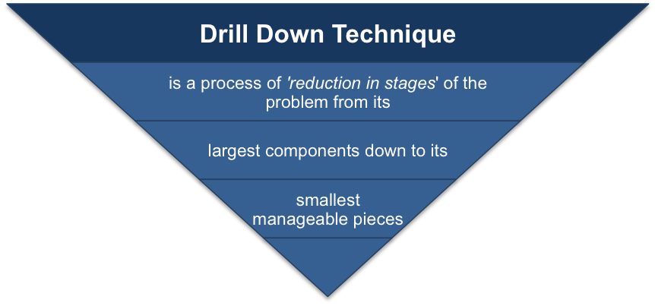
Figure 3 Drill down technique (Moreno, 2018)

2.3. Applying critical reasoning

An individual with critical thinking skills can evaluate data and reach an unbiased conclusion. You can reach reasonable conclusions that will guide your decision-making process by objectively assessing the relevant information. Employers place a high importance on the ability to properly analyse a situation and reach a logical and reasonable conclusion.
We developed the challenging matchstick puzzle game to incorporate this ability within our curriculum.

2.4. Process of applying critical reasoning

In order to methodically examine problems from a range of angles, a critical thinker will compile pertinent data. When analysing the data, they will apply reasoning and logic. Rather than taking concepts and presumptions at face value, they will explore and challenge them.

Sequence of activities | Activity | Start date – Finish date | Duration(in days) | Predecessors
A | Planning the Project | 2024/01/01 | 5
B | Selecting a school | 2024/01/06 | 5 | A
C | Assigning the roles and responsibilities | 2024/01/11 | 3 | B
D | Arrange the professional schedule | 2024/01/14 | 3 | C
E | Writing and finishing the project proposal | 2024/01/14 | 0 | D
F | Getting the approvals from the institute | 2024/01/14 | 0 | E
G | Getting permissions from the concerned parties | 2024/01/17 | 3 | F
H | Finalizing the event to conduct | 2024/01/22 | 5 | G
I | Arranging the required materials needed for the event | 2024/01/29 | 5 | H
J | Conducting rehearsals | 2024/02/01 | 3 | I
K | Delivery the event | 2024/02/02 | 1 | J
L | Write and submit the assignment | 2024/03/23 | 23 | K
Table 2 Critical path analysing of our event

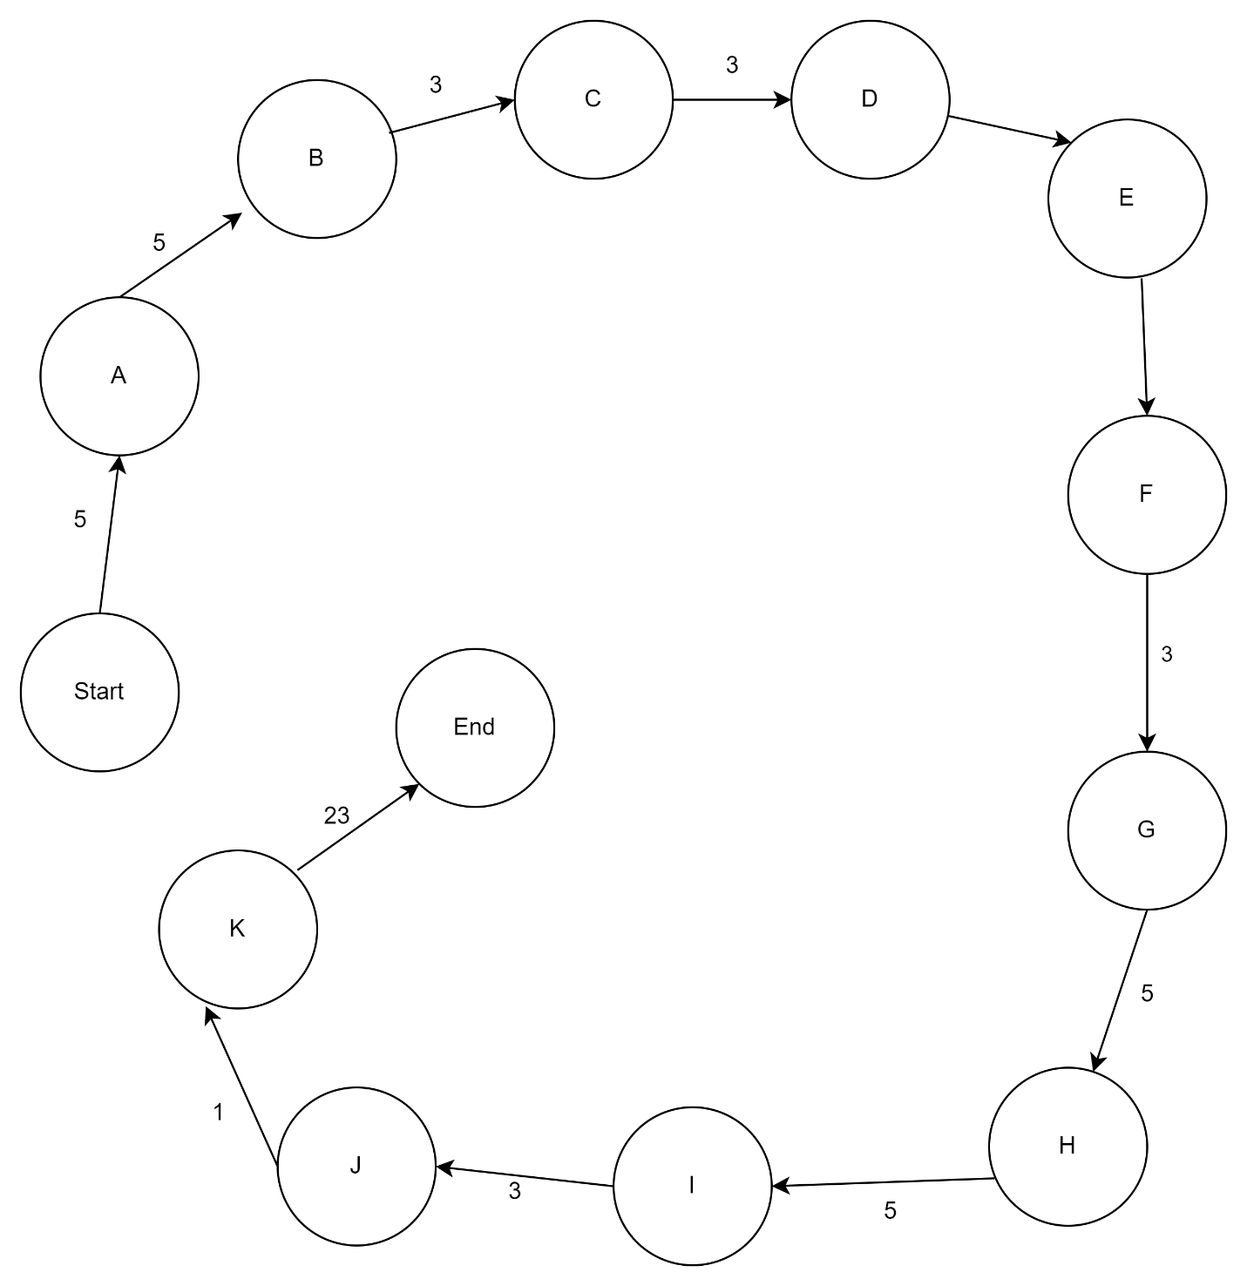
Figure 4 critical path analysing chart

Work in your team by contributing your skills and knowledge to meet the project goal. Critically evaluate your own role and contribution to the group for the completion of the training event.

3.1. Team Dynamics and Critical Evaluation

When a group of people collaborate to achieve a common objective, such connections, interactions, and processes are referred to as team dynamics. It covers decision-making, dialogue, cooperation, and dispute resolution among team members. When working in a team environment, successful team dynamics are essential to productivity.
Comparatively, critical evaluation entails doing a methodical and impartial analysis and assessment of data, claims, or concepts. It calls for critical thinking, the capacity to weigh opposing viewpoints, and the capacity to develop reasoned, evidence-based decisions. In order to solve issues, improve team or organisational procedures, and make wise judgements, critical assessment is necessary.

3.2. Self-Evaluation of Role and contribution

It entails considering one's own performance, obligations, and influence within a group or organisation while evaluating one's own role and contribution. In regard to their designated function and contributions to the team's objectives, each member must evaluate their own strengths, shortcomings, accomplishments, and areas for growth.
People should think about the quality of their work, the extent to which they have collaborated with others in the team, the overall influence of their contributions, and how well they have carried out their duties while evaluating themselves. Finding opportunities for improvement and development in one's performance requires self-evaluation that is sincere, impartial, and critical of oneself.
Individuals can become more self-aware, create improvement objectives, and increase their effectiveness in the team by self-evaluating their roles and contributions. It also gives people the chance to get input from others and modify their performance in order to maximise their contribution to the success of the team.

3.2. Importance of Dynamic Team Members

A team's performance and efficacy are greatly dependent on its dynamic individuals. Dynamic team members are crucial for the following main reasons.
1. Diverse Skills and viewpoints: Members that possess a dynamic nature contribute a wide array of skills, information, and viewpoints to the team. A wider range of ideas, improved decision-making, and more creative solutions can result from this diversity.
2. Flexibility: Dynamic team members have a fluid and adaptable work style. They are able to work well with varied team members, take on new projects, and quickly adapt to changing conditions.
3. Cooperation: People who are dynamic team players are adept at cooperating with others. They are able to form solid bonds with others, communicate clearly, and enhance team dynamics.
4.Dynamic team members take the initiative to recognise and address issues. This leads to proactive problem-solving. In order to get beyond challenges and accomplish team objectives, they are bold, resourceful, and inventive.
Dynamic team players exhibit motivation, enthusiasm, and engagement towards their task. They can encourage and inspire other team members with their upbeat demeanour and enthusiasm, which raises morale and productivity.
All things considered, dynamic team members are critical to creating a supportive environment for the team, stimulating creativity, and succeeding in a cooperative environment. The team performs better overall because of their varied skill set, flexibility, teamwork, problem-solving prowess, and drive.

3.3. Justification of Methodologies

Giving a justification for the selected research techniques, approaches, or procedures employed in a project or study is known as methodology justification. Giving a justification for the approach chosen and demonstrating how it fits with the goals, questions, and background of the research are crucial.
Research designers, data collection strategies, sample plans, data analysis processes, and ethical considerations are some of the elements that researchers usually take into account while justifying methodology. In addition to producing accurate and dependable results and adding to the corpus of existing knowledge in the subject, they should describe how the selected approaches will aid in addressing the research challenge.
Researchers can show the validity and rigour of their study, give their conclusions more credibility, and guarantee that the research is carried out ethically by giving a comprehensive explanation of their methods.

3.4. Evaluation of Event Success

An event's effectiveness and influence on accomplishing its goals and satisfying stakeholder expectations are evaluated as part of the evaluation process. In order to evaluate the overall effectiveness of the event, this procedure usually entails obtaining input, examining data, and monitoring key performance indicators.
Important factors to think about in assessing the success of an event are:
1. Goals: Evaluate if the occasion achieved its stated aims and purposes. This may encompass variables including the quantity of attendees, income earned, level of audience participation, and general contentment.
2. Feedback from stakeholders: To learn how other stakeholders felt about the event, get input from sponsors, suppliers, attendees, and others. Regarding areas of strength and progress, this comments might offer insightful information.
Indicators of key performance (KPIs): To gauge success, measure particular KPIs that were decided upon before the event. Metrics like media coverage, ticket sales, social media interaction, and post-event surveys may be included in this.
4. Budget and ROI: Examine the event's financial success by determining the ROI attained and contrasting real and budgeted costs. The cost-effectiveness and financial success of the event may be ascertained in this way.
5. Lessons learned: List the most important things to remember and the things you learned from organising and carrying out the event. Future event plans can benefit from this, and it can help make them more successful.
Organisers may improve their event planning and execution, uncover areas for improvement, and make well-informed decisions for subsequent events by thoroughly evaluating the success of their previous events.

3.5. Talk about Team Dynamic

The interactions, connections, and procedures that take place when a group of people collaborate to achieve a common objective are referred to as team dynamics. It includes the ways in which members of a team interact, communicate, decide, and settle disputes. Developing a healthy and productive work environment requires effective team dynamics.
Open communication, respect for one another, mutual trust, and teamwork are traits of positive team dynamics. A team's capacity for creativity, invention, and problem-solving can grow when members are at ease exchanging ideas, offering criticism, and cooperating to achieve a common goal.
Conversely, unfavourable team dynamics, like inadequate communication, mistrust, disagreements, and power struggles, can impair team effectiveness and lower morale and output. It is crucial because.

Discuss with examples, the importance of continuous professional development (CPD) in a work setting by evaluating the range of CPD criteria that can be used to measure the effectiveness of your employees in your organization.

4.1. What is CPD

A professional's continuous process of learning and growth to improve their abilities, know-how, and proficiency in their industry is known as continuing professional development, or CPD. Taking use of online courses, training programmers, conferences, seminars, workshops, and other educational opportunities are examples of CPD activities. In order to improve performance and advance their careers, CPD aims to keep professionals up to date on industry trends, laws, and best practices. Professional qualifications and licenses are maintained through continuing professional development (CPD), which is mandated by numerous sectors and organizations.

4.2. Importance of CPD

In order to remain current and competitive in their respective industries, professionals must engage in continuing professional development, or CPD. The following are some main arguments in favour of CPD's significance:
1. Skill Enhancement: Through continuing professional development (CPD), professionals can pick up new abilities, know-how, and proficiency that will help them adjust to the rapidly evolving business landscape and advances in technology.
2. Career Advancement: Participating in CPD events can improve one's chances of landing a job by showcasing one's dedication to professional development, which attracts employers.
3. Regulatory Compliance: In order to keep professional qualifications and licenses current, many businesses have required Continuing Professional Development (CPD) requirements. This guarantees that professionals adhere to industry norms and laws.
4. Personal Growth: Continuing Professional Development (CPD) offers avenues for individual growth and enhancement, promoting a feeling of achievement and contentment in one's professional life.
4.3. CPD’s contribution to own learning
The process that professionals go through to improve their knowledge, proficiency, and performance in their industry is known as continuing professional development, or CPD. Through possibilities for both professional and personal improvement, CPD plays a critical role in supporting an individual's own learning.
People can learn new skills, knowledge, and insights that are pertinent to their field of work through CPD activities like conferences, workshops, training programmes, online courses, and networking events. By keeping professionals abreast of developments, industry trends, and best practices, CPD enables professionals to adjust to changing circumstances and enhance performance.
People can improve their problem-solving skills, gain new knowledge, and feel more confident in their talents by taking part in CPD. In addition, CPD promotes critical thinking, self-reflection, and lifetime learning, which helps to maintain an ongoing cycle of growth and development.

Through ongoing education and skill development, CPD helps professionals reach their full potential, grow in their jobs, and remain competitive. As such, it makes a substantial contribution to personal learning.

4.4. Personal Development plan (PDP)

A Personal Development Plan (PDP) is a structured framework that helps individuals identify their strengths, weaknesses, goals, and strategies for personal and professional growth. A comprehensive PDP typically includes a skill audit, specific goals, strategies to achieve those goals, necessary resources, and time factors for implementation.

Name: |  |  |  | Current Position: |  |  |  |  | Date Started:
P. Nipuni Nethmini |  |  |  | HND Student
Career Mission Statement: (What you intend it accomplish and why)
Computer Networking Engineer – Become a Professional Network Engineer and builder career.
Major Career Goals: (Why you need to accomplished in the medium term to further your mission)
Goal: To complete the HND with all distinctions | Target Date: 2023/11/10 |  |  |  |  |  | Goal: To be a Networking Engineer |  |  | Target Date: By the end of 2026
Goal: To complete the degree in BSc (Computer Engineering) | Target Date: By the end of 2026 |  |  |  |  |  | Goal: To achieve the highest position in my carrier |  |  | Target Date: By the end of 2027
Skills Audit

A: I have accomplished this skill/I demonstrate high competence
B: I have this skill/competency but some improvement could be made
C: I need to improve this skill/competency
D: I need to put in considerable work to develop this competency
E: I need to acquire this kill/develop this competency
Skill/Competency |  | Rank |  |  |  |  |  | Skill/Competency |  |  | Rank
 |  | Now | 6 m |  | 1 year | 3 years |  |  |  |  | Now | 6 m | 1 year | 3 years
Team Building |  | B | A |  | A | A |  | Computer Literacy |  |  | B | B | A | A
Writing Skills |  | B | B |  | A | A |  | Self-Confidence |  |  | C | B | A | A
Speaking & Listening Skills |  | C | B |  | A | A |  | Flexibility |  |  | C | B | A | A
Making Decisions |  | B | B |  | A | A |  | Empowering others |  |  | B | B | A | A
Trustworthiness |  | B | B |  | A | A |  | Interpersonal Awareness |  |  | C | B | A | A
Planning and Organization |  | C | B |  | A | A |  | Problem Solving |  |  | C | C | B | A
Table 3 personal development plan

4.5. Motivational theories

Similar to maps, theories of motivation investigate why we act in particular ways and what motivates us to work towards our objectives. They demonstrate to us the influence that our needs, wants, and objectives have on our motivation. (Shiwakumar, 2024)

1. Maslow's Hierarchy of requirements: This theory postulates that human motivation is based on a hierarchy of requirements, ranging from more fundamental physiological needs (like food and shelter) to aspirational wants (like self-actualization). When wants at a lower level are met, people are inspired to fulfil demands at a higher level.
2. The theory of Herzberg's Two Factor: According to Herzberg, there are two categories of elements that affect job satisfaction and motivation: hygienic factors (like pay and working circumstances) that help avert discontent, and motivators (like achievement and recognition) that foster motivation and fulfilment.

3. McClelland’s Theory of Needs: The three basic needs that motivate human behaviour accomplishment, affiliation, and power are the centre of McClelland's Theory of Needs. Individuals are motivated by one or more of these wants, according to this idea, and figuring out which need is strongest can assist explain and anticipate how they will behave at work.
4. Vroom’s Theory of Expectancy: According to this hypothesis, people are driven to behave a specific way because they think their efforts will produce the results they want. In order to encourage people, it highlights how crucial it is to link effort, performance, and incentives.
5. Mc Gregor’s Theory X and Theory Y: According to equity theory, people get motivated when they believe that their activities (skills, effort) and results (rewards, recognition) are just and equal in relation to others. Feelings of unfairness and a decrease in motivation might result from perceived equity imbalances.
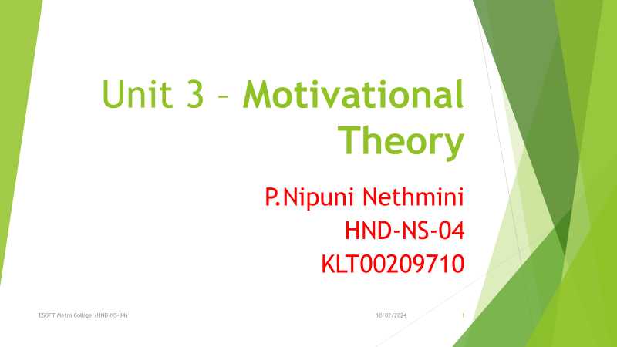
Figure 5 motivational theory 1
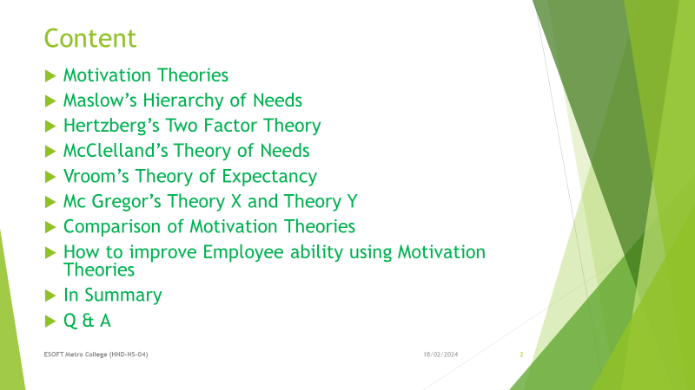
Figure 6 motivational theory 2
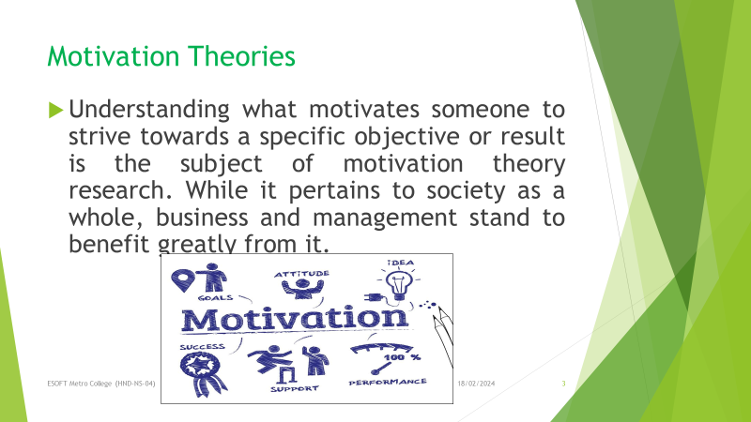
Figure 7 motivational theory 3

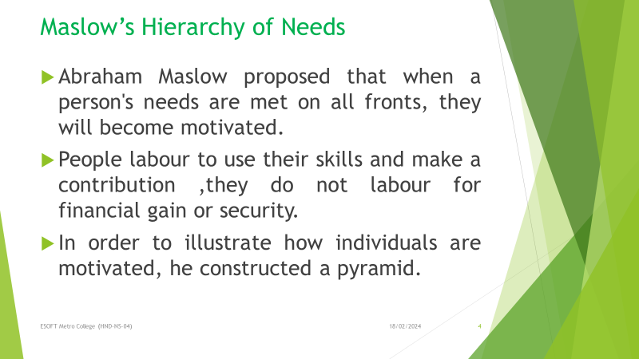
Figure 8 motivational theory 4

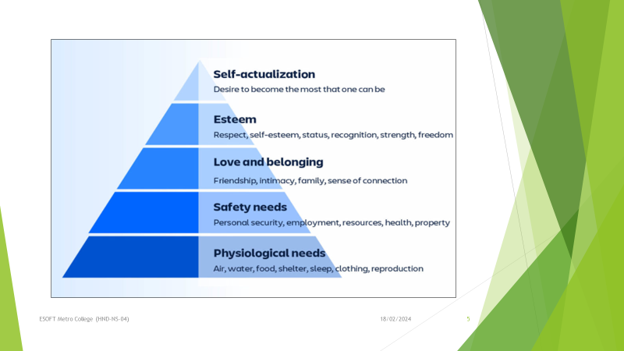
Figure 9 motivational theory 5
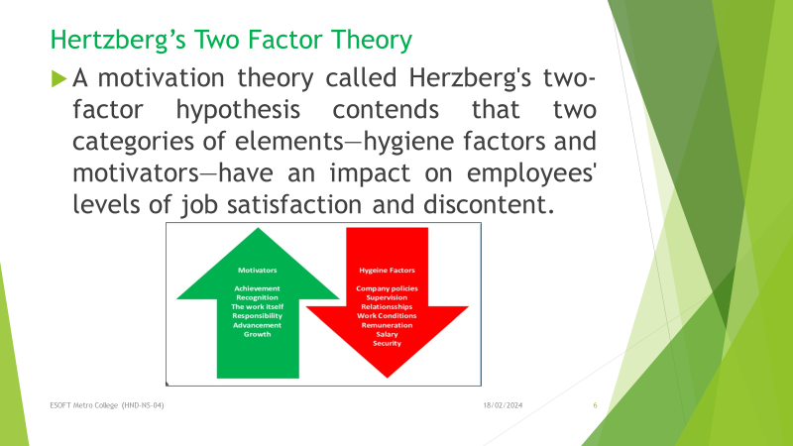
Figure 10 motivational theory 6

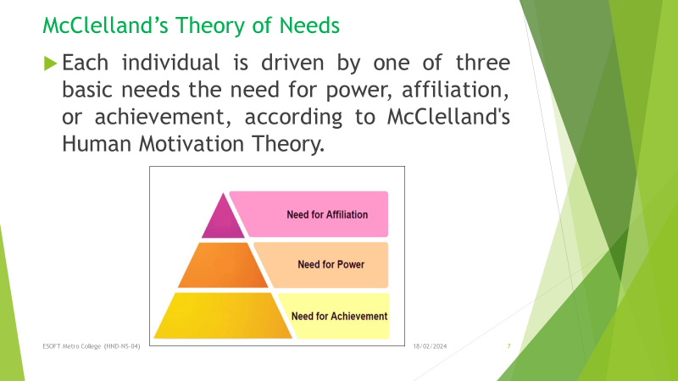
Figure 11 motivational theory 7
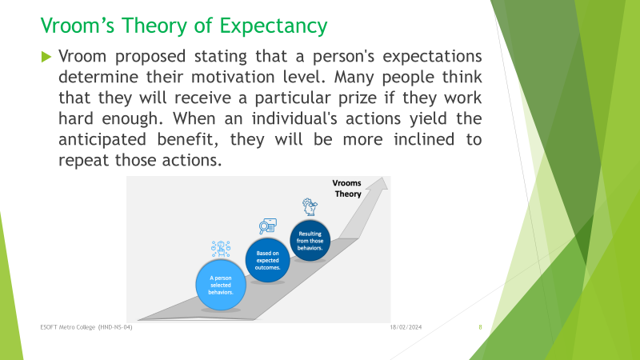
Figure 12 motivational theory 8

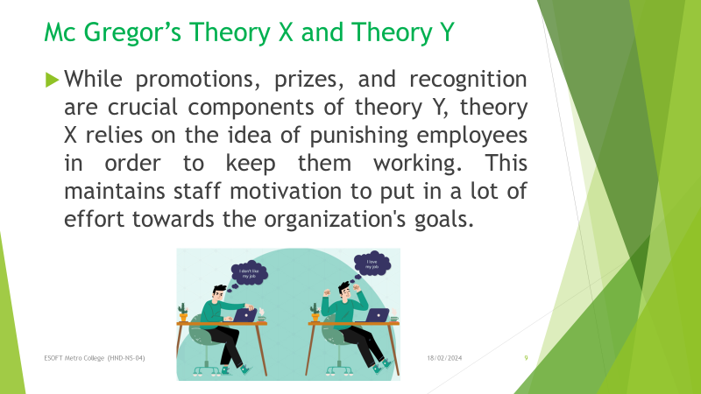
Figure 13 motivational theory 9
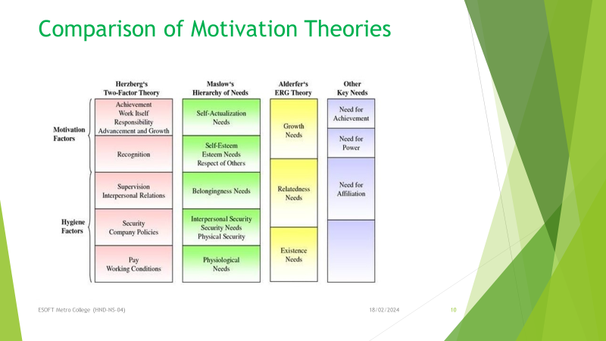
Figure 14 motivational theory 10
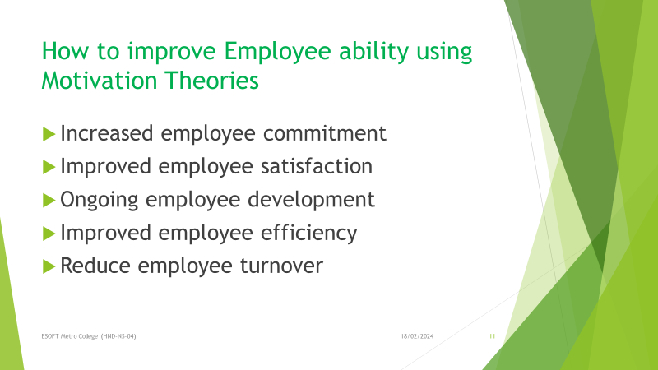
Figure 15 motivational theory 11
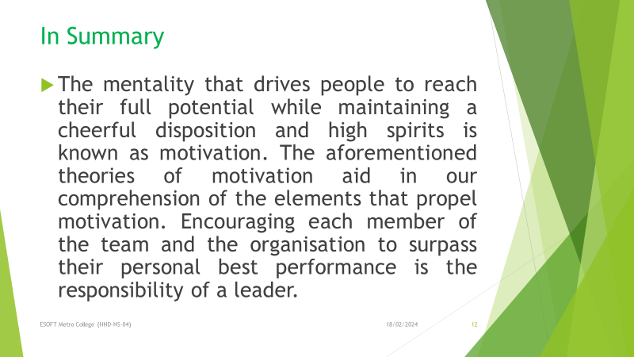
Figure 16 motivational theory 12

Figure 17 motivational theory 13
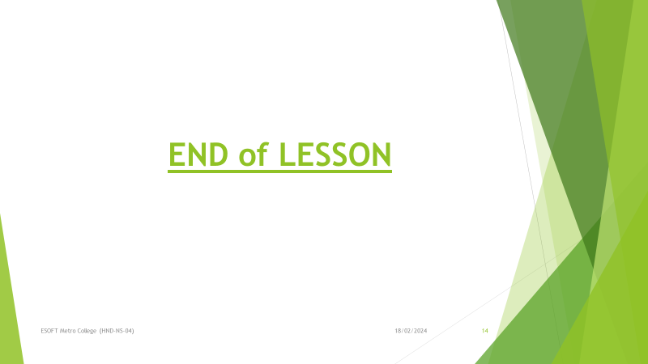
Figure 18 motivational theory 14

Theory | Focus | Strengths | Weaknesses
Maslow’s Hierarchy | Needs pyramid (physiological, safety, social, esteem, self-actualization) | Clear framework, basic needs force | Universal order may not hold, doesn’t explain individual differences
Herzberg’s Two-Factor | Hygiene(dissatisfaction) | Hygiene vs. motivation destination, useful for workplace design | Doesn’t explain factor strength, limited view of motivation
McClelland’s Needs Theory | Three core needs (achievement, affiliation, power) | Recognizes individual differences in motivation useful for understanding specific drivers for individuals | Needs are subjective, may not encompass all motivations
Vroom’s Theory | Belief in effort performance reward link | Focuses on the cognitive process of motivation | Assumes rationality, ignores emotions and social factors
Theory X & Theory Y | Three psychological needs (autonomy, competence) | Emphasizes intrinsic motivation | Limited explanation in situations with external pressures
Table 4 comparison motivational theories

4.6. Impact they can have on performance within the workplace

The theory of motivation is a vital component in determining how employees perform at work. Businesses may build an environment that supports increased productivity, engagement, and pleasure by understanding what motivates their staff. Here's how to do it:
Comprehending Needs: Theories of motivation such as Maslow's Hierarchy of Needs [1] argue that people are motivated by a sequence of needs ranging from fundamental physiological requirements to achieving self-actualization. Businesses may develop a work environment that meets these criteria by knowing them. For example, providing possibilities for growth and development satisfies higher-level wants, while delivering fair salaries and benefits takes care of basic requirements.
Increasing Engagement: Theories that distinguish between hygienic elements and motivators—such as demanding work and recognition—include Herzberg's Two-Factor Theory [2]. Motivators are essential for fostering involvement, whereas hygienic considerations guard against discontent. Dissatisfaction is avoided by hygienic considerations, yet participation is fuelled by motivators. Employers may establish a work atmosphere where employees are enthusiastic and invested in their roles by concentrating on motivators.
Better Results: Expectancy theory [3] posits that an employee's motivation is impacted by their perception that their efforts will yield valuable results and that these results will constitute a return on investment. Employers may reinforce this notion and motivate staff to give it their all by establishing clear goals, giving constructive criticism, and providing substantial rewards.
Lower Turnover: Happy employees are motivated employees. Employers can discover elements like a lack of possibilities for advancement or recognition that lead to employee dissatisfaction by using motivation theories. Through the resolution of these issues, businesses can establish a work environment that attracts and keeps outstanding talent.
4.8. Evaluating the range of evidence criteria
Assessing Data to Determine Performance Effects of Motivational Theory
Using the given criteria, the following is an analysis of how we might assess the evidence regarding the effect of motivational theory on performance:
Information:
Production Data: This is a reliable source of information. Metrics like sales numbers, output rates, project completion schedules, and error rates can be compared before and after motivational theory-based interventions are put into practice. This enables us to investigate the possibility of a relationship between motivational techniques and enhanced performance.
Personal Information: Although useful, this needs to be carefully considered. Employee impressions of motivation, engagement, and job satisfaction can be gleaned through surveys or interviews. These could be impacted by various circumstances and are subjective.
Judging Techniques Based on Group Work during Training Events:
When used alone, this may be a weak source of information. Training activities may provide participants with an introduction to motivational theories and their potential advantages, but their efficacy in the real world may not always follow.
Evaluation:
Advantages: The most impartial and quantitative proof is provided by production statistics.
Weaknesses: Personal information may not accurately reflect performance because it is subjective. There is no practical applicability for training exercises.
Extra Points to Remember:
Control Groups: Research should ideally compare groups that are given motivational interventions with groups that are not given any. This makes it easier to discern how the intervention affects performance.
External Validity: Not every workplace will experience the same outcomes from a single study or training programme. When assessing evidence, take into account the particular industry, the culture of the organisation, and the personnel base.

Annexure

Meeting Minutes Annexure

Google meets social media for team members. The minutes of the meeting we held are listed below.

It was the result of three cooperative meetings that our programme was completed successfully. We had frank and fruitful conversations throughout these get-togethers, giving everyone a chance to share their opinions. We created a thorough plan that successfully took into account the goals and aspirations of each member by actively listening to one other and respectfully taking into account all points of view. Our ability to recognise and handle possible obstacles while leveraging our strengths was made possible by the platform that the sessions provided for group brainstorming. Through collaborative efforts and a common goal, we made sure that the program's conception and implementation reflected our group's objectives

First Meeting Minute
Meeting Minutes

Project Code | Professional practice - Work Related Learning Report: Design and Deliver Training Programme
Client Name and Product Name | N/a
Date and Time | Date:28/12/2023, Time:19.45 - 20.45
Venue | Google Meet
Purpose of the Meeting | To discuss Team members idea about the event
Participants | Samitha, Anfal, Eshan, Dinindu, Rumana, Gishan, Thimash, Sasini, Dilan, Nethmi, Sanjali, TharuNethmi, Abdul, Deshan, Nipuni, Ashen
Excused
Absentees | N / Ap
Table 5 First meeting minutes
Discussed Topics
# | Item | Raised by
1 | Dress Code – T-Shirt | Eshan Fernando
2 | Program Plan 1. Show 2. Program | Samitha Dulakshana
3. | Show – 5 (Arduino, Hardware, Quiz, Soft Skill, VR) | Gishan Weeraratna
4. | Arduino Show | Ashen, Abdul Azeez, Deshan
5. | Hardware Assemble | Eshan,  Ttharunethmi,  Nethmi, Anfal
6. | Quiz | Rumana, Sanjali,  Dilshan, Sadun
7. | Soft Skill | Dilan, Chameera  Fernando, Sasini  Dilanjana, Nipuni
8. | VR Show | Thimash, Yenuka,  Pehesara

Action Items.
# | Item | Responsibility | Due Date | Status | Comment
1 | Prepare the project proposal | Sasini | 01/02/2024 | Pending | We should include about our event plan  and team members names and roles
2 | Prepare the permission letter | Deshan | 08/02/2024 | Pending | We should include the purpose of the event
3 | Prepare the project plan | Samitha | 15/02/2024 | Pending | In Project plan we should include our shows details and time management.

Next Meeting
Date | 07/01/2024 | Time |  | 13.00 - 15.00
Venue |  | ESOFT
Agenda |  | Budget
Minutes recorded by |  | A.A. Rumana Begum

Meeting Minutes

# | Item | Responsibility | Due Date | Status | Comment
1 | Prepare the project proposal | Sasini | 01/02/2024 | Pending | We should include about our event plan and team members names and roles.
2 | Prepare the permission letter | Deshan | 08/02/2024 | Done | We should include the purpose of the  event. We can include about our chief guests.
3 | Prepare the project plan | Samitha | 15/02/2024 | Pending | In Project plan we should include our shows details and time management.

Project Code | Professional practice - Work Related Learning Report : Design and Deliver Training Programme
Client Name and Product Name | N/a
Date and Time | Date: 07/01/2024, Time: 13.00 - 15.00
Venue | Esoft
Purpose of the Meeting | Budget Planning
Participants | Samitha, Anfal, Gishan, Dinindu, Sadun, Dilan, Eshan, Deshan, Sanjali, Nipuni, Rumana, Sasini, Nethmi, Tharunethmi, Yenuka
Excused
Absentees | N / Ap
Table 6 second meeting minutes
Discussed Topics
# | Item | Raised by
1 | Confirmed Budget | Tharunethmi, Nethmi,Nipuni
2 | Confirmed Dress Code | Deshan
3 | Confirmed Event Plan | Yenuka, Anfal

Action Items

Next Meeting
Date | 21/01/2024 | Time | 20.30 to 22.30
Venue |  | Google Meet
Agenda |  | How to do the Program
Minutes recorded by |  | A.A. Rumana Begum

Meeting Minutes

# | Item | Responsibility | Due Date | Status | Comment
1 | Prepare the project proposal | Sasini | 01/02/2024 | Done | We should include about our event plan and team members names and roles.
2 | Prepare the permission letter | Deshan | 08/02/2024 | Done | We should include the purpose of the event. We can include

Project Code | Professional practice - Work Related Learning Report : Design and Deliver Training Programme
Client Name and Product Name | N/a
Date and Time | Date: 01/02/2024, Time: 20.00 – 21.00
Venue | Google Meet
Purpose of the Meeting | Discuss more things about the event and rehearsal.
Participants | Samitha, Gishan, Eshan, Dilshan, Sadun, Anfal, Yenuka, Ashen, Sasini, Rumana, Sanjali, Nethmi, Tharunrthmi, Deshan, Dilan
Excused
Absentees | N / Ap
Table 7 third meeting minutes

Discussed Topics
# | Item | Raised by
1. | Refreshment | Chameera  Fernando
2. | Feedback Form | Sadun
3. | Decoration | Dilan
4. | Confirmed Rehearsal date (25/02/2024) | Sanjali
5. | Time Management | Dilshan
Action Items
 |  |  |  |  | about our chief guests.
3 | Prepare the project plan | Samitha | 15/02/2024 | Pending | In Project plan we should include our shows details and time management.
Next Meeting
Date | 15/02/2024 | Time | 19.00 to 20.00
Venue |  | Google Meet
Agenda |  | Discuss about the rehearsal
Minutes recorded by |  | A.A Rumana Begum

Annexure 2

Project Proposal

PROJECT PROPOSAL

FutureITis



Project location:
Organized by: Group A, HND NS4 Batch
Supervised by:

Table of Contents
1. Table of Contents 1
1. Our team 2
2. Introduction 3
3. Problem statement 4
4. Objectives 4
5. Plan of action 5
6. Management plan 6
Table 1 – Event schedule 6
Table 2 – Budget plan 7
7. Conclusion 8
8. Project approval 9

Our team
Student name | Registration number | post
Samitha Dulakshana | 209017 | Team leader
Rumana Begum | 192393 | Monitor eveluetar
Thimash Shanuka | 212732 | coordinator
Sasini dulanjana | 195452 | coordinator
Tharunethmi Apurwa | 215546 | Team worker ( Treasurer )
Nethmi Malsha | 170957 | Team worker ( Treasurer )
Nipuni Nethmini | 209710 | Team worker ( Treasurer )
Gishan Weeraratna | 193161 | Recourse investigator
Dilan Rajitha | 208566 | Plant
Dilshan Chathuranga | 221620 | Implementer
Sandun Chathura | 201913 | Team worker ( Quizer )
Anfal | 197534 | Finisher
Abdul Azees | 209808 | Team worker
Sanjale Samindara | 213122 | Shaper
Deshan | 207158 | Shaper
Chameera Fernando | 206162 | Team worker
Ashen Pradeepa | 195979 | Team worker (Ardinonator)
Akash Pahasara | 197214 | Team worker
Yenuka Rangana | 197534 | Team worker
Eshan Fernando | 201263 | Specialists

Introduction

IT and soft skills development is a comprehensive approach aimed at cultivating a versatile and effective professional. It involves enhancing technical competencies in Information Technology (IT), such as programming, cybersecurity, and system administration, alongside fostering essential interpersonal skills, including communication, teamwork, adaptability, and time management. This combination empowers individuals to excel not only in technical tasks but also in collaborative environments, making them well-equipped to navigate the dynamic and evolving landscape of the IT industry.

Problem statement
The students of HND NS4 batch have got an assignment to the subject of Professional Practice. In order to complete the assignment, we have organized a IT & soft skills development project in Kalutara balika College . Our selected group of students are from Grade 11.

Objectives

- Our main target is to develop the following skills;
- Encouraging and motivating students.
- Improving leadership qualities.
- Develop IT knowledge
- Learn IT Opportunities
- Develop effective communication skills.
- Develop effective presentation skills.
- Pursuing towards a common goal.
- Handling work load effectively while maintaining good interpersonal relationships.
- Take part effectively in various selection procedures adopted by the recruiters.

Plan of action

Forming teams
- We expect the participation of 150 students approximately.
- Prior to the event we have to arrange the place in the way we are convenient with.
- We need a spacious area as our venue.

Events
The organizing members play a crucial role in guiding the students through our planned activities. To streamline our efforts, each of us will be assigned to oversee a specific activity. These designated team members will then present the nature and rules of their respective activities to the participants. The ultimate decision regarding the games will be collectively made by our team.

Our focus is on conducting three distinct activities aimed at fostering creativity, honing time management skills, and enhancing problem-solving abilities among the participants. Our goal is to deliver optimal experiences to the participants within a limited timeframe.

Management plan
Duration of the program: 8.30 am – 01.00 pm
Arrival From: 7.00 am
Reached At: 7.30 am
Organize students for the event: 8.30 am
Event | Duration
Event | From | To
Separate students into groups and bring them from class & Introduction | 8.30 am | 8.45 am
Hardware, Quiz, Soft skill Game, Ardino & VR shows | 8.45 am | 10.30 am
Soft Skill Game show’s Final Round | 10.30 am | 10.45 am
Break/Everyone goes & sits Program hall / Breakfast | 10.45 am | 11.00 am
Reception of guests, Lightning oil Lamp, Religious Worship | 11.00 am | 11.15 am
Introduction video & Leader Speech | 11.15 am | 11.25 am
Leader, Youtuber & Actor Speech Program | 11.25 am | 12.00 pm
Esoft Metro College – kalutara Branch Manager Speech | 12.00 pm | 12.10 pm
Grant of Certificates | 12.10 pm | 12.20 pm
Guest Music Artist Show | 12.20 pm | 12.35 pm
School Principal Speech | 12.35 pm | 12.45 pm
Final Grand of Certificates | 12.45 pm | 12.55 pm
National Anthem & End Program | 12.55 pm | 01.00 pm
The schedule of our event is;
Table 8 Event schedule
Budget plan for the event is:
Item | Quantity | Price (Rs)
Beverages (Milk packet) | 200 | 200 x 100 | 20,000.00
Food (Cutlet) | 200 | 200 x 20 | 4000.00
Food (cake) | 5 KG | 5 x 1000 | 5000.00
Cameraman | - | - | 15,000.00
VR box | 5 | 5 x 800 | 4000.00
Ardino gadgets | - | - | 4500.00
Transport | - | - | 1000.00
Others | - | - | 2000.00
Total |  |  | 55,500.00
Table 9 Budget plan

Conclusion
In summary, the cultivation of IT and soft skills stands as an indispensable necessity in the contemporary and interconnected landscape of today. These interpersonal proficiencies, encompassing communication, empathy, adaptability, and leadership, extend beyond specific industries and job roles, providing individuals with the tools to flourish in both their professional and personal lives. In the face of advancing automation and technology, the intrinsic value of human-centric skills becomes increasingly evident, enabling individuals to forge robust relationships, encourage collaboration, and adeptly navigate intricate challenges. Through a commitment to developing soft skills, individuals can elevate their career trajectories, evolve into adept team contributors, and excel in leadership roles. Embracing the potency of soft skills fosters a society marked by empathy, innovation, and harmony, shaping a promising and brighter future for all.

Project approval

Approval signatures:

…………………………………………….
Lecturer/ Assessor (Name)

……………………………………………..
Branch Manager (Name)

Annexure 4

Event Photos

Soft Skill Development Program

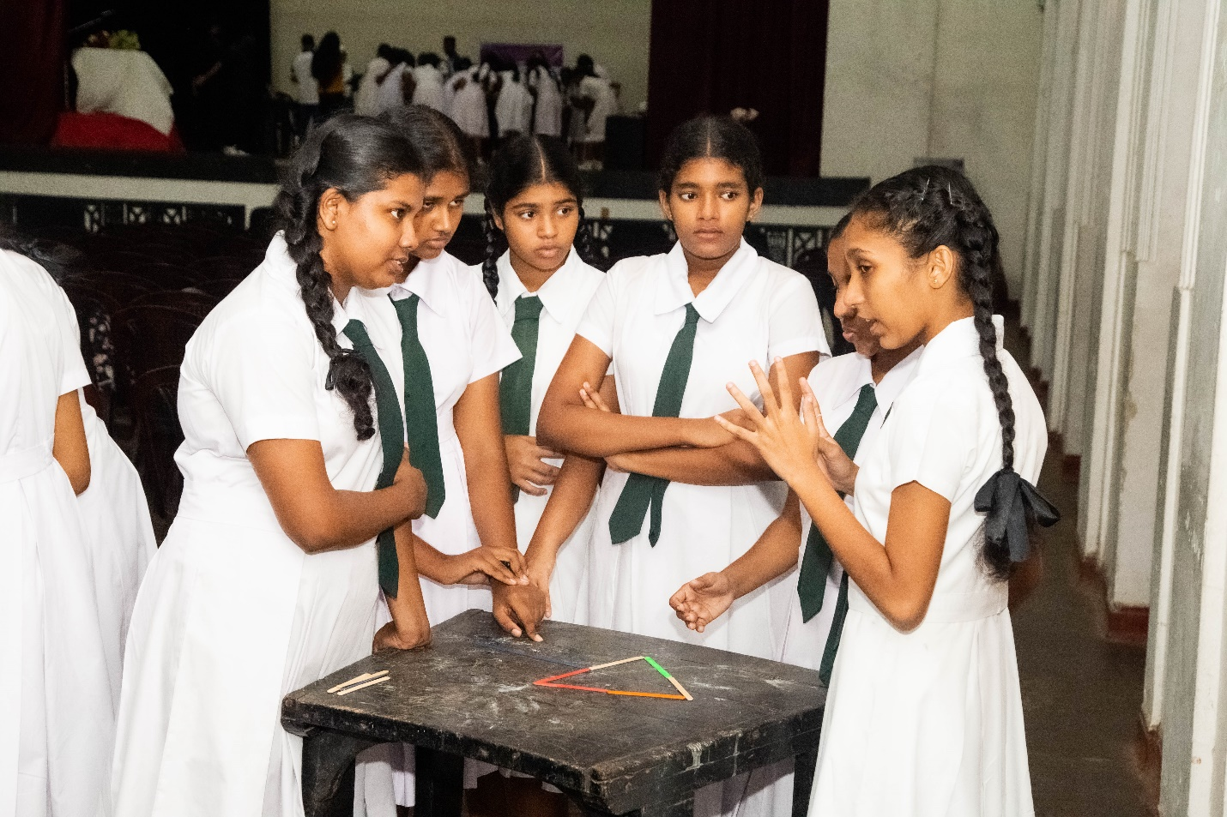
Figure 19 soft skill development program

Hardware Show

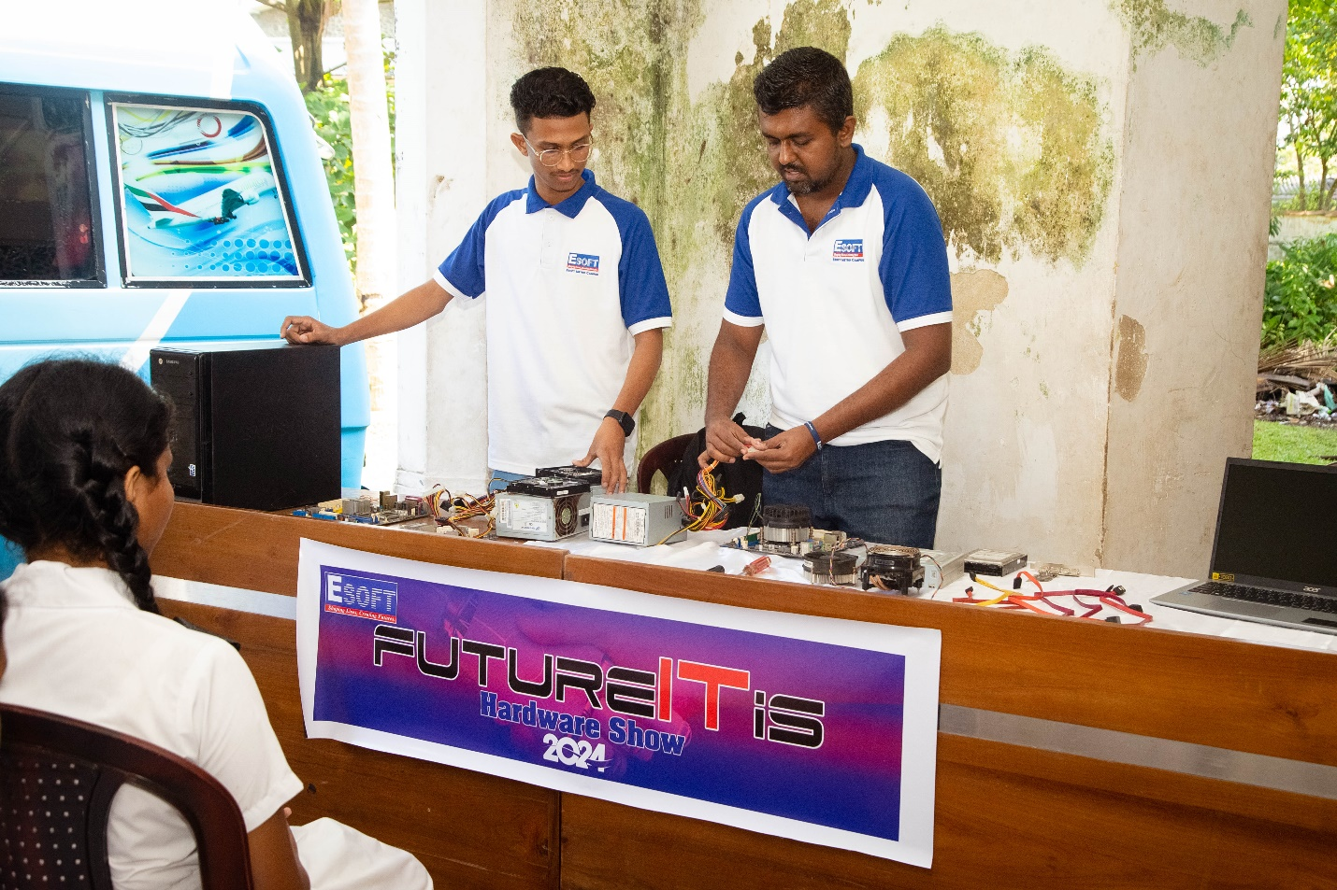
Figure 20 hardware show

VR Show

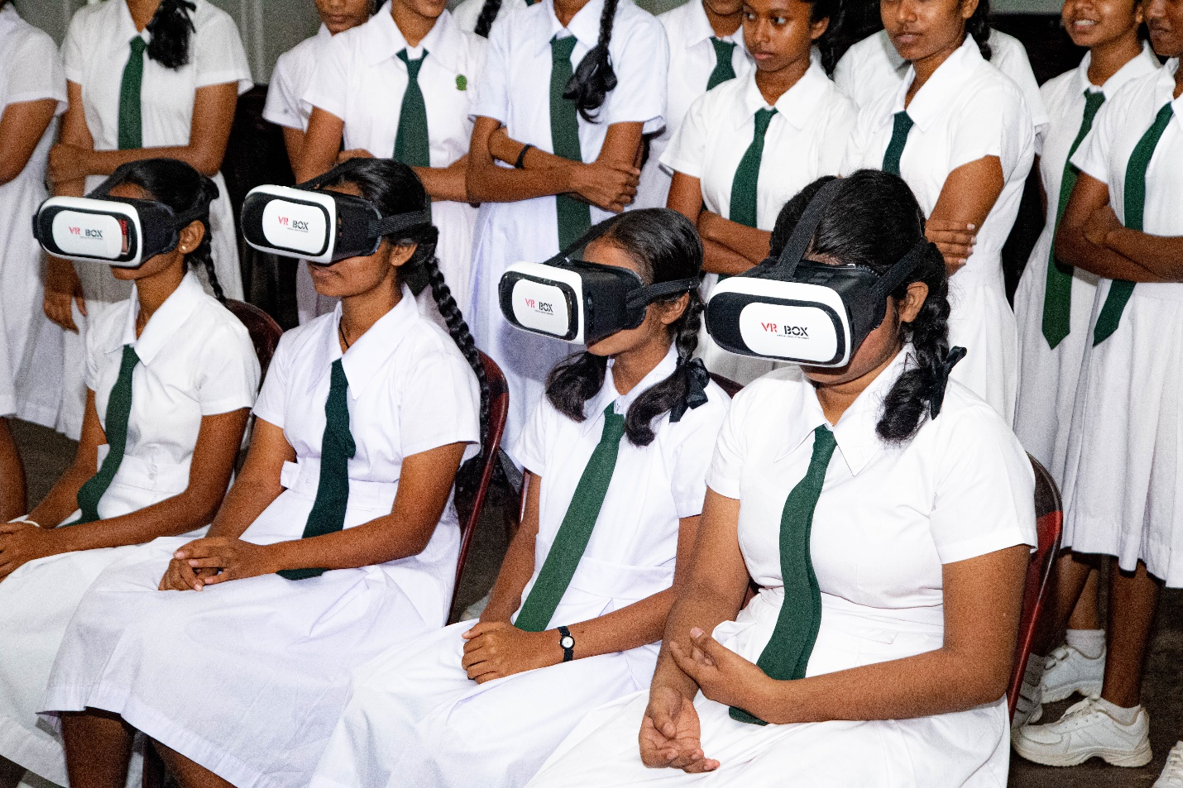
Figure 21 vr show

Quiz Program

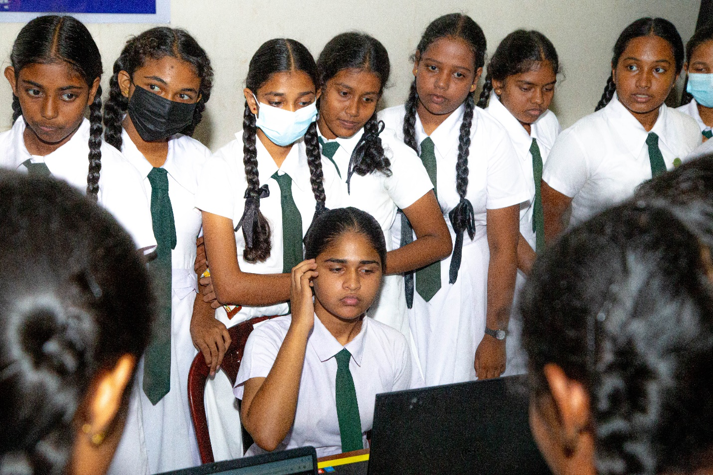
Figure 22 quiz program

Ardino Show

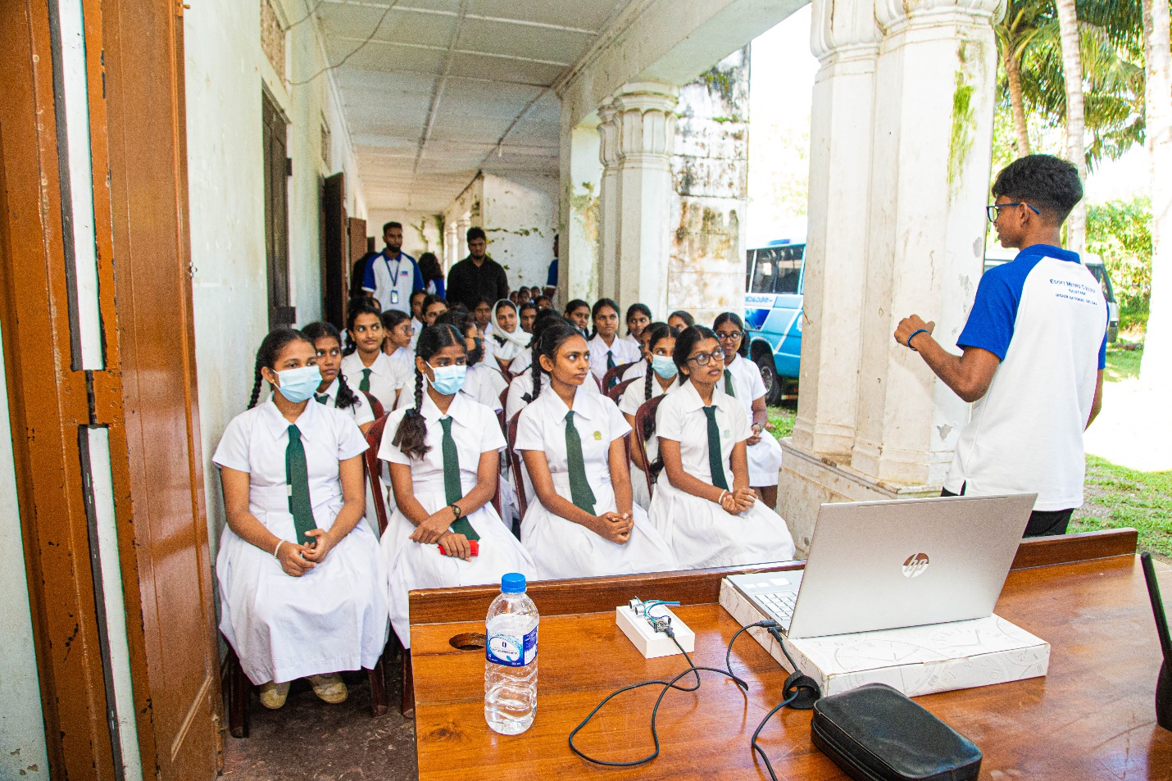
Figure 23 ardino show
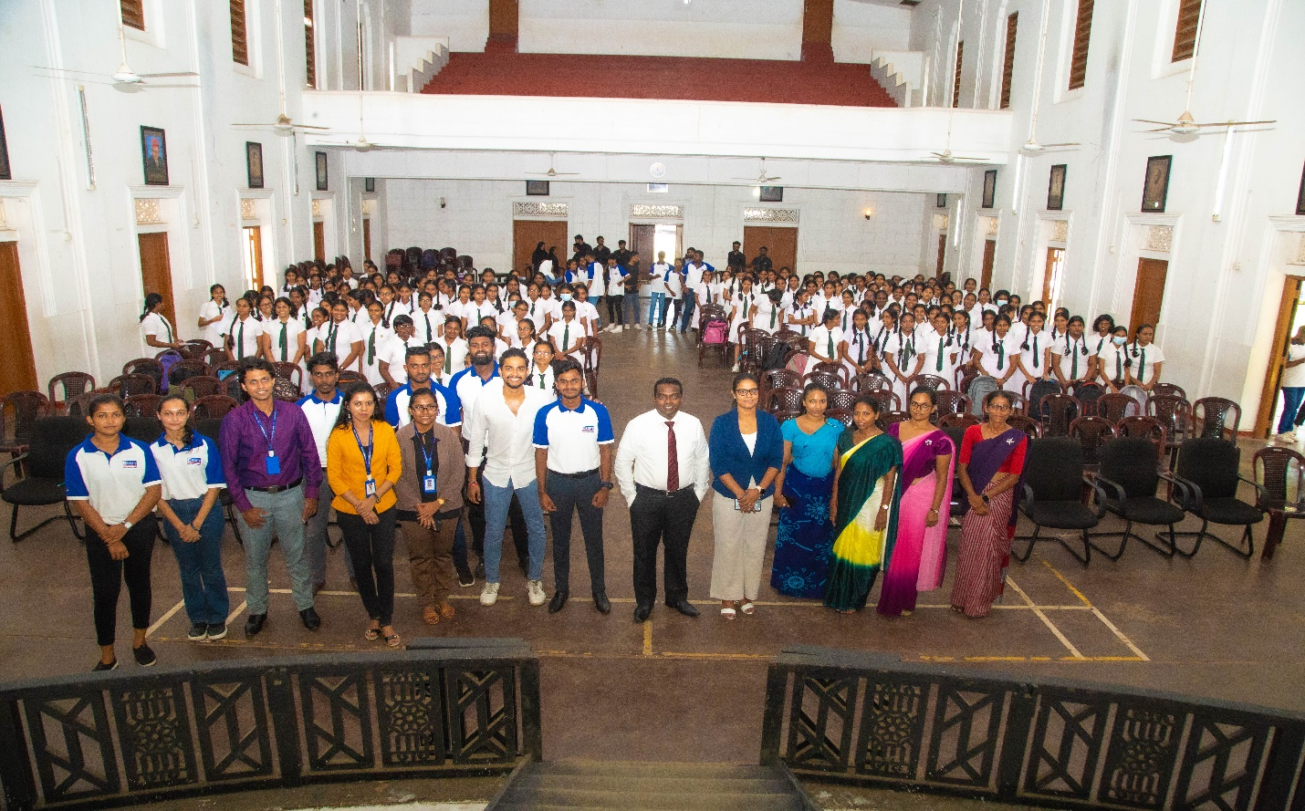
Figure 24
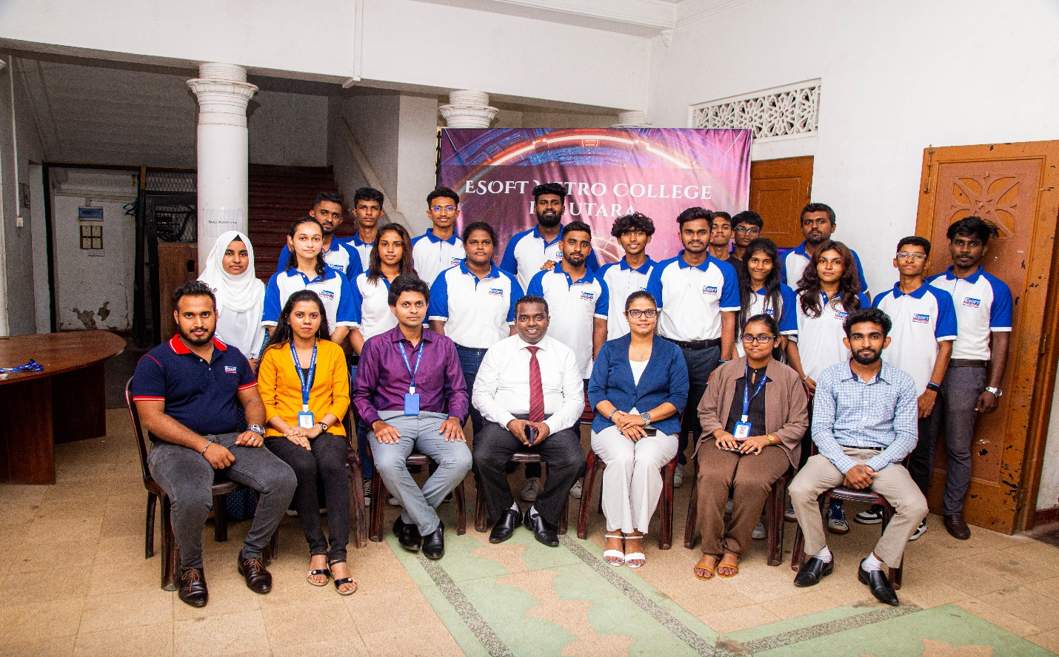
Figure 25
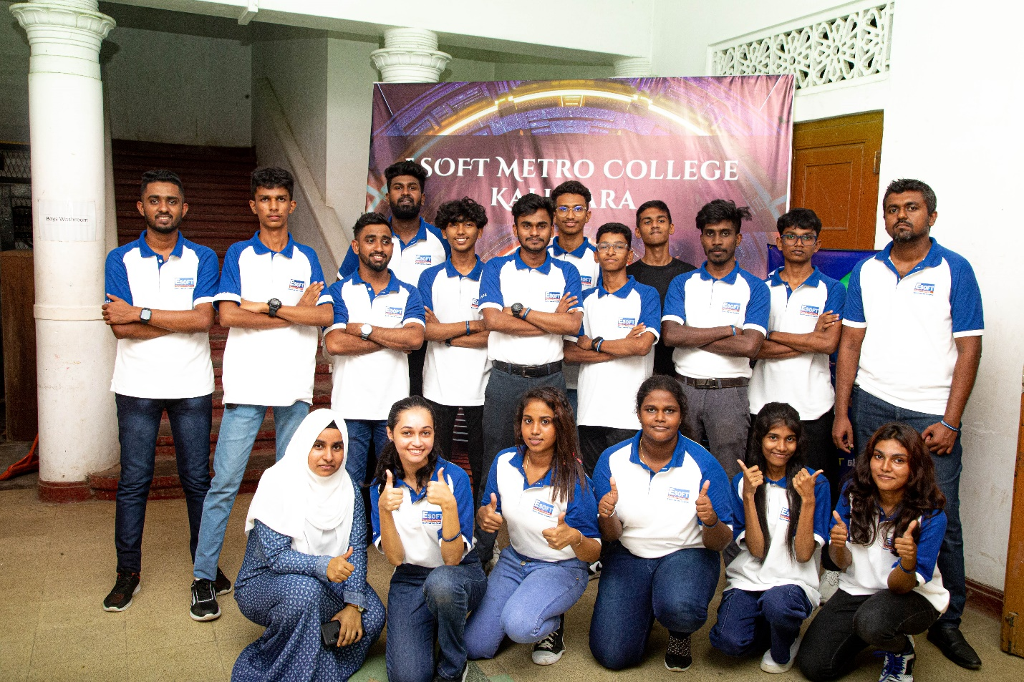
Figure 26

Annexure 5

Approval Letter

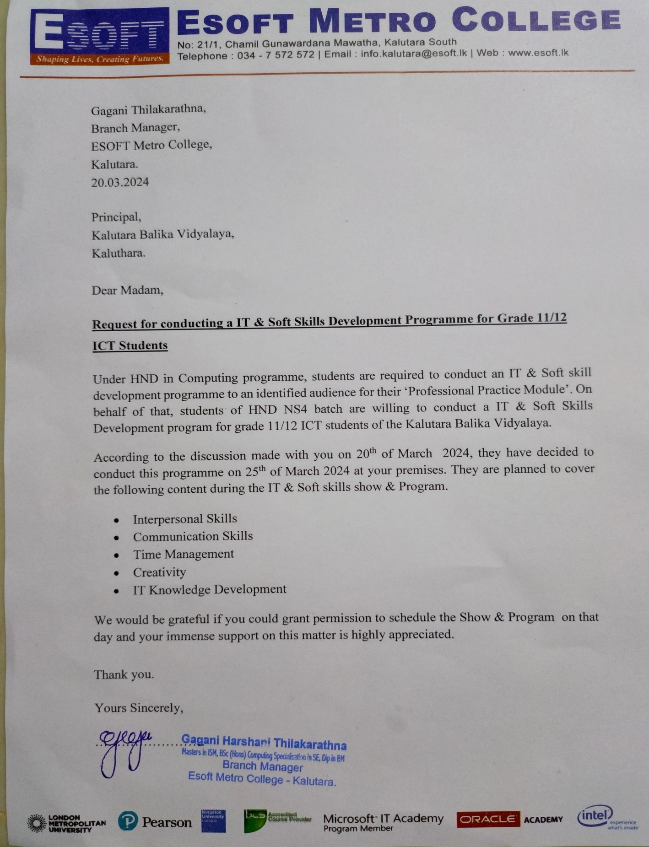
Figure 27 Approval letter

Bibliography
Moreno, O., 2018. Linked in. [Online]
Available at: https://www.linkedin.com/pulse/drill-down-technique-orlando-moreno-pmp-acm-cnse-6sigma-agile-osha
SHEVONEESE, 2019. Mac Social. [Online]
Available at: https://shevoneese.school.blog/2019/07/15/the-importance-of-smm/
Shiwakumar, K., 2024. upGrad. [Online]
Available at: https://www.upgrad.com/blog/what-are-motivation-theories/
[Accessed 23 january january].

Grading Rubric

Grading Criteria | Achieved | Feedback
LO1 Demonstrate a range of interpersonal and transferable communication skills to a target audience. | 19 – 27
P1 Demonstrate effective design and delivery of a training event for a given target audience, using different communication styles and formats | 21 – 22
P2 Demonstrate effective time-management skills in planning an event. | 19 – 20
M1 Design a professional schedule to support the planning of an event, to include contingencies and justifications of time allocated. | 22 – 25
D1 Evaluate the effectiveness and application of interpersonal skills during the design and delivery of a training event. | 26 – 27
LO2 Apply critical reasoning and thinking to a range of problem-solving scenarios. | 26 - 32
P3 Demonstrate the use of different problem-solving techniques in the design and delivery of an event. | 26
P4 Demonstrate that critical reasoning has been applied to the design and delivery of the event | 26
M2 Research the use of different problem-solving techniques used in the design and delivery of an event. | 27
M3 Justify the use and application of a range of methodologies in the design and delivery of an event. | 30 - 32
D2 Evaluate the overall success of the event delivered, in terms of how well critical reasoning and thinking were applied to achieve the end goal. | 30
LO3 Discuss the importance and dynamics of working within a team and the impact of team working in different environments. | 31 - 34
P5 Discuss the importance of team dynamics in the success and/or failure of group work. | 31
P6 Work within a team to achieve a defined goal. | 31
M4 Analyse team dynamics, in terms of the roles group members play in a team and the effectiveness in terms of achieving shared goals. | 32 - 33
D3 Critically evaluate your own role and contribution to a group scenario. | 33 – 34
LO4 Examine the need for Continuing Professional Development (CPD) and its role within the workplace and for higher-level learning. | 36 – 51 3
P7 Discuss the importance of CPD and its contribution to own learning. | 36
P8 Review different motivational theories and the impact they can have on performance in the workplace. | 39 - 47
P9 Produce a development plan that outlines responsibilities, performance objectives and required skills for future goals. | 40 - 41
M5 Justify the role of CPD and development planning in building motivation. | 39
D4 Evaluate a range of evidence criteria that is used as a measure for effective CPD. | 50 - 51

